Purpose : This Doc describes the Use Case Diagram and detailed description of the functionalities of Employee.

    - Employee -

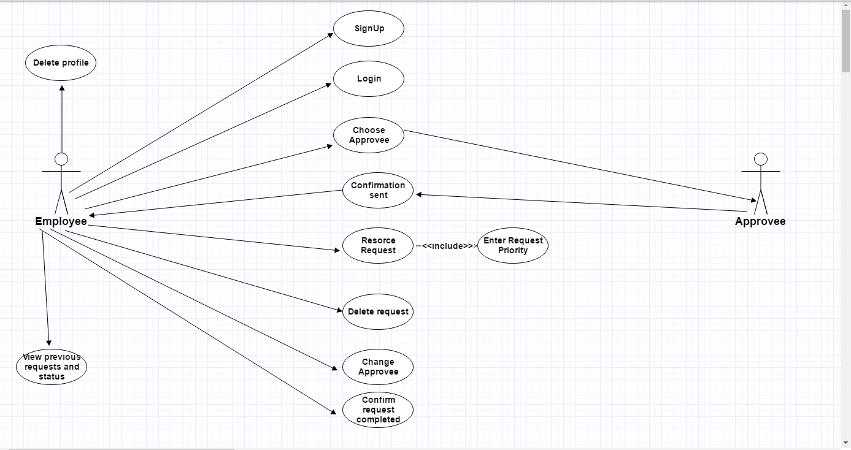

Detailed Description :

    - Sign Up :

Employee will be firstly sign up for registration in this portal.And he/she should be comulsory to add his/her designtaion.

2. Choose Approvee:

Employee can choose approvee of his/her project.So that request for resources will be sent to that approvee directly.
Approvee will be team lead in case of developer /tester/designer.
Approvee will be manager if employee is team lead.
Approvee will be CEO if employee is manager.

3. Confirmation sent :

When approvee of particular employee approve employee then confirmation sent to him/her.

4. Resource request:

Employee can request for resources and at the time of requesting it is compulsory to enter priority of that request.

5. Delete request:

Employee can delete their resource request at any time interval.

6. Change approvee :

Employee can update their approvee in case if he/she is going to another project.

7.Confirm request completed:

After completion of request of resource it should be compulsory that he/she should change status of confirmation.

8.View previous requests and status:

Employee can view their previous requests and their status :confirmed/completed/due/pending at any point of time.

